**MYSQL PROJECT: Library Management System**

Topic : Library Management System

Created by hanan

iam going to build a project based on Library Management System. It keeps track of all information about books in the library, their cost, status and total number of books available in the library.

Create a database named library and following TABLES in the database:

1. Branch
2. Employee
3. Books
4. Customer
5. IssueStatus
6. ReturnStatus

create database library;

create table branch(

branch_no char(4) primary key,

manager_id int,

branch_address varchar(20),

contact_no char(10));

insert into branch(branch_no,manager_id,branch_address,contact_no )values

('BR01','1','westbranch01','1234567890'),

('BR02','2','westbranch02', '1234567891'),

('BR03','3','westbranch03', '1234567892'),

('BR04','4','eastbranch01', '1234567893'),

('BR05','5', 'eastbranch02', '1234567894'),

('BR06','6', 'eastbranch03', '1234567895');

select* from branch;

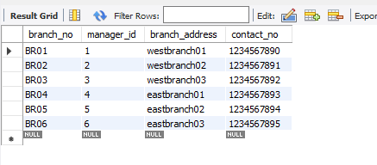

create table employee(emp_id int primary key,emp_name varchar(30) ,position varchar(20) ,salary decimal(7,2) ,

branch_no char(4),foreign key(branch_no)references branch(branch_no));

insert into employee(emp_id,emp_name,position,salary,branch_no)values

(1,'alice smith','ceo',65000.00,'BR01'),

(2,'jane doe','assistant',50000.00,'BR01'),

(3,'johannas burg','executive assistant',52000.00,'BR02'),

(4,'john williams','ceo',65000.00,'BR03'),

(5,'henry davis','manager',55000.00,'BR04'),

(6,'bob dylan','marketting head',54000.00,'BR03'),

(7,'jacob kuriyan','hr',57000.00,'BR05'),

(8,'ann mariya','ceo',65000.00,'BR06'),

(9,'anna george','manager',55000.00,'BR01'),

(10,'githaa anjali','marketting head',54000.00,'BR02'),

(11,'arumon','executive assistant',52000.00,'BR01'),

(12,'sonnigam','marketting head',54000.00,'BR01'),

(13,'sundar reddy','hr',57000.00,'BR01'),

(14,'zoya young','ceo',65000.00,'BR02'),

(15,'anna bell','assistant',50000.00,'BR05');

select* from employee;

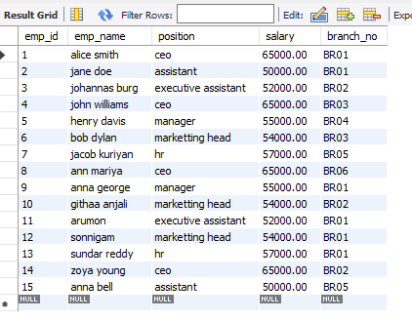

create table books(ISBN char(13) primary key,book_title varchar(50)

,category varchar(20),rental_prize int,status varchar(3),author varchar(20),

publisher varchar(30));

insert into books(ISBN,book_title,category,rental_prize,status,author,publisher)values

(9781594036152,'a rat is a pig is a dog is boy','classic',100,'yes','smith','encounter book'),

(9780060210982,'all the place to love','romantic',70,'no','patricia','harpercollins'),

(9781590784655,'an amish year','fiction',200,'150','richard','harpercollins christian'),

(9780689647696,'apples to oregon','genaral',20,'yes','deporah hopkinson','simon and schuster'),

(9781936959120,'buzz into action','general',30,'yes','alexander david','random house disney'),

(9780143432821,'the magic of the lost temple','fiction',25,'no','sudha murthy','penguin random house'),

(9789350195611,'junior leval books introduction to computer','computer',100,'yes','amit garg','readers zone'),

(9798894156255,'lucifer was innocent:the red pill','horrer',200,'no','tirth raj parsana','notion press'),

(9789359896779,'the haunted:series 1','fiction',150,'no','vipraj singh ranawat','blue rose'),

(9780857197689,'the psychology of money','genaral',75,'yes','morgon housel','jaicopublishing house'),

(9780143109464,'me before you','romantic',80,'yes','jojo moyes','penguin uk'),

(9780143498674,'something i never told you','romantic',90,'no','shravya bhinder','penguin random house'),

(9781602833364,'brave new world','fiction',40,'no','aldous huxley','chato and windus'),

(9780694524440,'the alchemist','fiction',100,'no','poulo coelho','harper collins'),

(9781428108325,'pride and prejudice','classic',90,'yes','jane austen','dover publications');

select* from books;

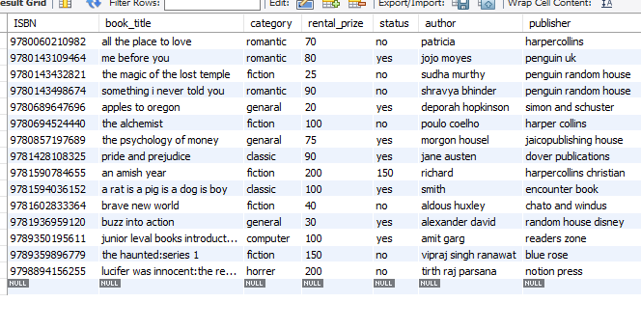

create table customer(cust_id int primary key,cust_name varchar(30),cust_address varchar(30),reg_date date);

insert into customer(cust_id,cust_name,cust_address,reg_date)values

(1,'aloshi kurian','123mainstreet','2023-11-04'),

(2,'alice smith','124mainstreet','2024-08-19'),

(3,'jane doe','125mainstreet','2020-07-14'),

(4,'bob dylan','123mainstreet','2023-04-04'),

(5,'jacob george','124mainstreet','2024-07-06'),

(6,'ann mariya','123mainstreet','2023-07-09'),

(7,'anna george','125mainstreet','2022-09-17'),

(8,'anabella','123mainstreet','2020-04-11'),

(9,'geetha beli','123mainstreet','2022-09-12'),

(10,'rose jack','125mainstreet','2021-08-05'),

(11,'james','125mainstreet','2022-09-12'),

(12,'george','123mainstreet','2021-08-14'),

(13,'david','126mainstreet','2020-06-23'),

(14,'emil das','124mainstreet','2022-02-14'),

(15,'anjali','123mainstreet','2021-03-26');

select* from customer;

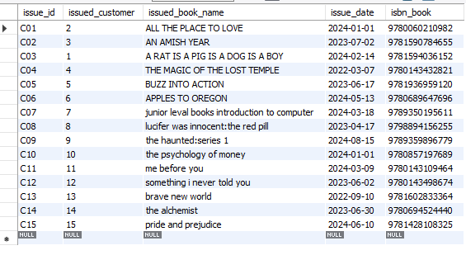

create table issue_status (issue_id VARCHAR(10) primary key, issued_customer int,

foreign key(issued_customer)references customer(cust_id),

issued_book_name varchar(50),issue_date date,isbn_book varchar(20),foreign key(isbn_book)references books(ISBN));

insert into issue_status(issue_id,issued_customer,issued_book_name,issue_date,isbn_book)values

('C01',2,'ALL THE PLACE TO LOVE','2024-01-01',9780060210982),

('C02',3,'AN AMISH YEAR','2023-07-02',9781590784655),

('C03',1,'A RAT IS A PIG IS A DOG IS A BOY','2024-02-14',9781594036152),

('C04',4,'THE MAGIC OF THE LOST TEMPLE','2022-03-07',9780143432821),

('C05',5,'BUZZ INTO ACTION','2023-06-17',9781936959120),

('C06',6,'APPLES TO OREGON','2024-05-13',9780689647696),

('C07',7,'junior leval books introduction to computer','2024-03-18',9789350195611),

('C08',8,'lucifer was innocent:the red pill','2023-04-17',9798894156255),

('C09',9,'the haunted:series 1','2024-08-15',9789359896779),

('C10',10,'the psychology of money','2024-01-01',9780857197689),

('C11',11,'me before you','2024-03-09',9780143109464),

('C12',12,'something i never told you','2023-06-02',9780143498674),

('C13',13,'brave new world','2022-09-10',9781602833364),

('C14',14,'the alchemist','2023-06-30',9780694524440),

('C15',15,'pride and prejudice','2024-06-10',9781428108325);

select* from issue_status;

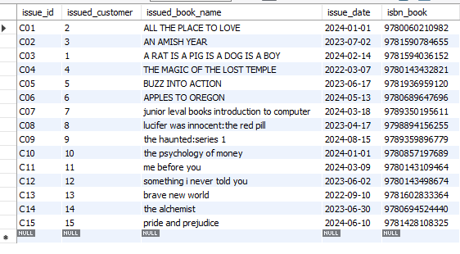

create table return_status(return_id varchar(10) primary key,return_cust INT,return_book_name varchar(50),

return_date date,isbn_book2 varchar(20),foreign key(isbn_book2)references books(ISBN));

insert into return_status(return_id,return_cust,return_book_name,return_date,isbn_book2)values

('R01',1,'A RAT IS A PIG IS A DOG IS A BOY','2024-05-18',9781594036152),

('R02',6,'APPLES TO OREGON','2024-07-03',9780689647696),

('R03',5,'BUZZ INTO ACTION','2024-01-11',9781936959120),

('R04',7,'junior leval books introduction to computer','2024-06-11',9789350195611),

('R05',10,'the psychology of money','2024-03-16',9780857197689),

('R06',11,'me before you','2024-07-09',9780143109464),

('R07',15,'pride and prejudice','2024-07-12',9781428108325);

select* from return_status;

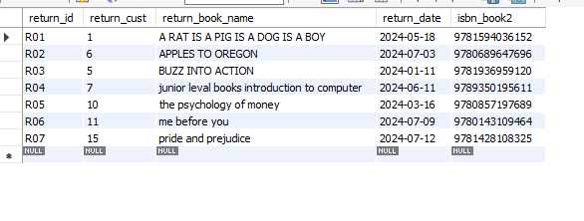

 1. Retrieve the book title, category, and rental price of all available books.

select book_title,category,rental_prize from books;



1. List the employee names and their respective salaries in descending order of salary.

select emp_id, emp_name ,salary from employee order by salary desc;

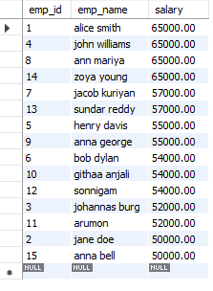

1. Retrieve the book titles and the corresponding customers who have issued those books.

select issue_status.issued_customer,

issue_status.issued_book_name,customer.cust_name from issue_status left join customer

on issue_status.issued_customer=customer.cust_id;

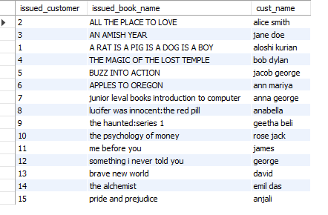

1. Display the total count of books in each category.

select count(book_title)as no_of_books,category from books group by category;

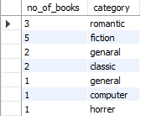

1. Retrieve the employee names and their positions for the employees whose salaries are above Rs.50,000.

select emp_name,position,salary from employee where salary>50000.00;

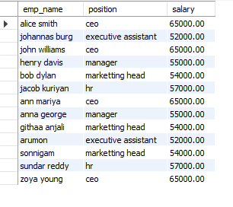

1. List the customer names who registered before 2022-01-01 and their issued books.

select customer.cust_name ,customer.reg_date,issue_status.issued_book_name from customer left join issue_status on

customer.cust_id=issue_status.issued_customer where

customer. reg_date<'2022-01-01';

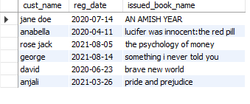

1. Display the branch numbers and the total count of employees in each branch.

select count(emp_id) as no_of_employees,branch_no from employee group by branch_no;

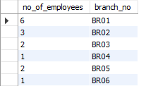

1. Display the names of customers who have issued books in the month of June 2023.

select customer.cust_name,issue_status.issued_book_name,issue_status.issue_date from

customer left join issue_status on customer.cust_id=issue_status.issued_customer where

issue_status.issue_date between '2023-06-01' and '2023-06-30';

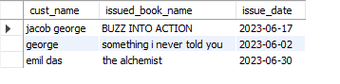

1. Retrieve book_title from book table containing fiction.

select book_title,category from

books where category='fiction';

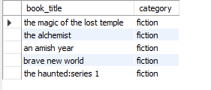

10.Retrieve the branch numbers along with the count of employees for branches having more than 5 employees

select branch_no,count(emp_id) as no_of_employees from employee group by branch_no having count(emp_id)>5;



11.Retrieve the names of employees who manage branches and their respective branch addresses.

select employee.emp_name, employee.branch_no,branch.branch_address from employee left join branch on

employee.branch_no=branch.branch_no ;

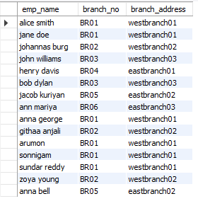

12. Display the names of customers who have issued books with a rental price higher than Rs. 25.

select customer.cust_name ,books.book_title,books.rental_prize from customer inner join issue_status

on customer.cust_id=issue_status.issued_customer inner join books on issue_status.isbn_book=books.ISBN where books.rental_prize>25;